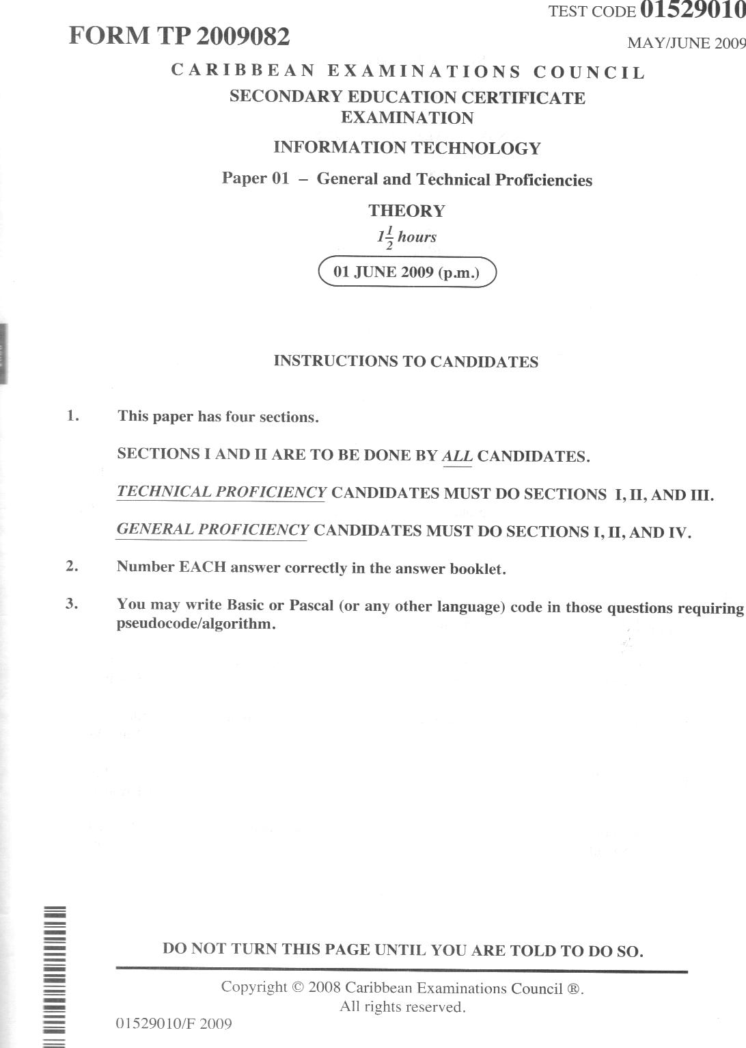

- 2 -
SECTIONS I and II
TECHNICAL AND GENERAL PROFICIENCIES
ANSWER ALL QUESTIONS.
SECTION 1-30 marks
1. (a) Write the labels A, B, C, and D on separate lines, one below the other, in your answer booklet. Then write the term input, output,processing or storage next to the letter that
best describes the stage as shown in the diagram below.
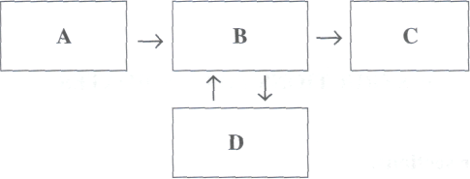
(4 marks)
(b) For EACH of the terms input, output, processing and storage, write ONE example of a
device that is used to perform this operation. ( 4 marks)
Total 8 marks
2. Floppy disks were once the usual medium for saving files.
- Describe ONE example where it would still be sensible to use a floppy disk for software
distribution. (1 mark )
- State TWO different devices, other than floppy disks, that are used to store files.
(2 marks)
(c) Using the two devices that you chose in 2 (b), state which ONE might hold more files.
(1 mark)
(d) Suppose you decided to e-mail your work to your personal e-mail address. Describe
ONE advantage and ONE disadvantage of doing this. ( 2 marks)
Total 6 marks
GO ON TO THE NEXT PAGE 01529010/F 2009
- 3 -
3. Compute the following:
- The eight-bit binary representation of the decimal number 14. (1 mark )
- The sign-and-magnitude representation for the decimal number NEGATIVE 14.
(1 mark)
- The result of 55 - 25, using eight-bit two's complement representation. Express your
answer as an eight-bit binary number. ( 3 marks)
- The decimal equivalent for the binary coded decimal number 0011 0110 0000.
(2 marks)
Total 7 marks
4. You have hired a company to create a software package called ABC specifically for your business.
- State the general name given to this type of software package. (1 mark )
- Suppose you bought a package similar to ABC, called FGH, 'off-the-shelf.
(i) Explain what is meant by 'off-the-shelf. (1 mark )
(ii) Describe ONE advantage and ONE disadvantage EACH of
- hiring someone to create ABC
- buying FGH. (4 marks)
(c) Suppose you wished to use ABC to integrate with your other software packages used in the business.
(i) Explain why you would want to integrate them. ( 2 marks)
(ii) Give ONE disadvantage that you might have in integrating these programs.
(1 mark)
Total 9 marks
GO ON TO THE NEXT PAGE
01529010/F 2009
- 4 -
SECTION II - 30 marks
5. Write the list of applications A to E from Table 1 in your answer booklet. Match EACH application with the MOST appropriate input device from Table 2 and write the number of the device chosen next to the application.

Table 1
Table 2

 | APPLICATIONS
A | Point-of-sale
B | Games
C | Architectural design
D | Multiple-choice examination
E | Check processing
 | INPUT DEVICES
1 | optical mark reader
2 | barcode reader
3 | magnetic ink character recognition
4 | joystick
5 | plotter

Total 5 marks

6. (a)
(b)

Identify TWO industries in which robots are useful.
(2 marks)
State ONE advantage EACH of using robots in EACH industry identified in 6 (a).
(2 marks)

(c) State ONE disadvantage of using robots in industry.
(1 mark) Total 5 marks

7. Consider the following encryption code where each letter of a password represents a different letter in the alphabet (A is represented as G, B as H, C as I and so on).

Password letters | X | Y | Z | A | B | C | D | E | F | G | H | I | J | K | L
Encryption letters | D | E | F | G | H | I | J | K | L | M | N | O | P | Q | R

(a)
(i) What is the encription code for the password HIKE?
(1 mark)

(ii) If the encrypted password is represented as RED what is the real password?
(1 mark)
(b) What is the purpose of having a password?
(1 mark)

- Within many organizations, data can be stored in a central location where staff in various
departments can have access to them. Describe TWO problems that may arise because
of sharing these data. ( 2 marks)
Total 5 marks
01529010/F 2009 GO ON TO THE NEXT PAGE

- 5 -
8. (a) James is a computer trainer while Rachel is a systems analyst. Give ONE function of
EACH of these roles. ( 2 marks)
(b) Give the meaning of the following terms:
(i) Telemarketing (1 mark)
(ii) Telecommuting (1 mark)
(iii) Teleconferencing (1 mark)
Total 5 marks
9. (a) Explain what is meant by'computer-related crime'. (1 mark)
- Give TWO examples of computer-related crime. ( 2 marks)
- Give TWO steps that can be taken to help prevent computer-related crime.
(2 marks)
Total 5 marks
10. The Computers for Caribbean Schools project provides at least one computer for all classrooms.
- State TWO ways in which the computers can be used in the classroom. ( 2 marks)
- One class added two other devices to their computer and can now bª8ture copies of their
own photographs, create greeting cards and print them. State the TWO devices that
were added. ( 2 marks)
- One class connected their computer to the Internet. List ONE way in which they can
protect their computer from getting viruses. (1 mark )
Total 5 marks
GO ON TO THE NEXT PAGE 01529010/F2009

- 6 -
TECHNICAL PROFICIENCY
THIS SECTION IS FOR TECHNICAL PROFICIENCY CANDIDATES ONLY.
SECTION III - 30 marks
PROGRAMMING ANSWER ALL QUESTIONS
11. (a) Draw a flowchart to represent the following algorithm:
(i) Prompt the user to enter an integer (1 mark )
(ii) Read the integer and store in variable N (1 mark )
(iii) Divide the number by 2 and store the remainder in variable ANS (1 mark ) (iv) If ANS is
- zero (0), multiply N by itself (N*N) and place the result in variable Y
- not zero (0), multiply N by 2 (N*2) and place the result in Y
( 3 marks)
(v) Print the answer (Y). (1 mark )
(b) Calculate and write the value that will be printed if the number input is 13.
(1 mark)
Total 8 marks
GO ON TO THE NEXT PAGE 01529010/F 2009

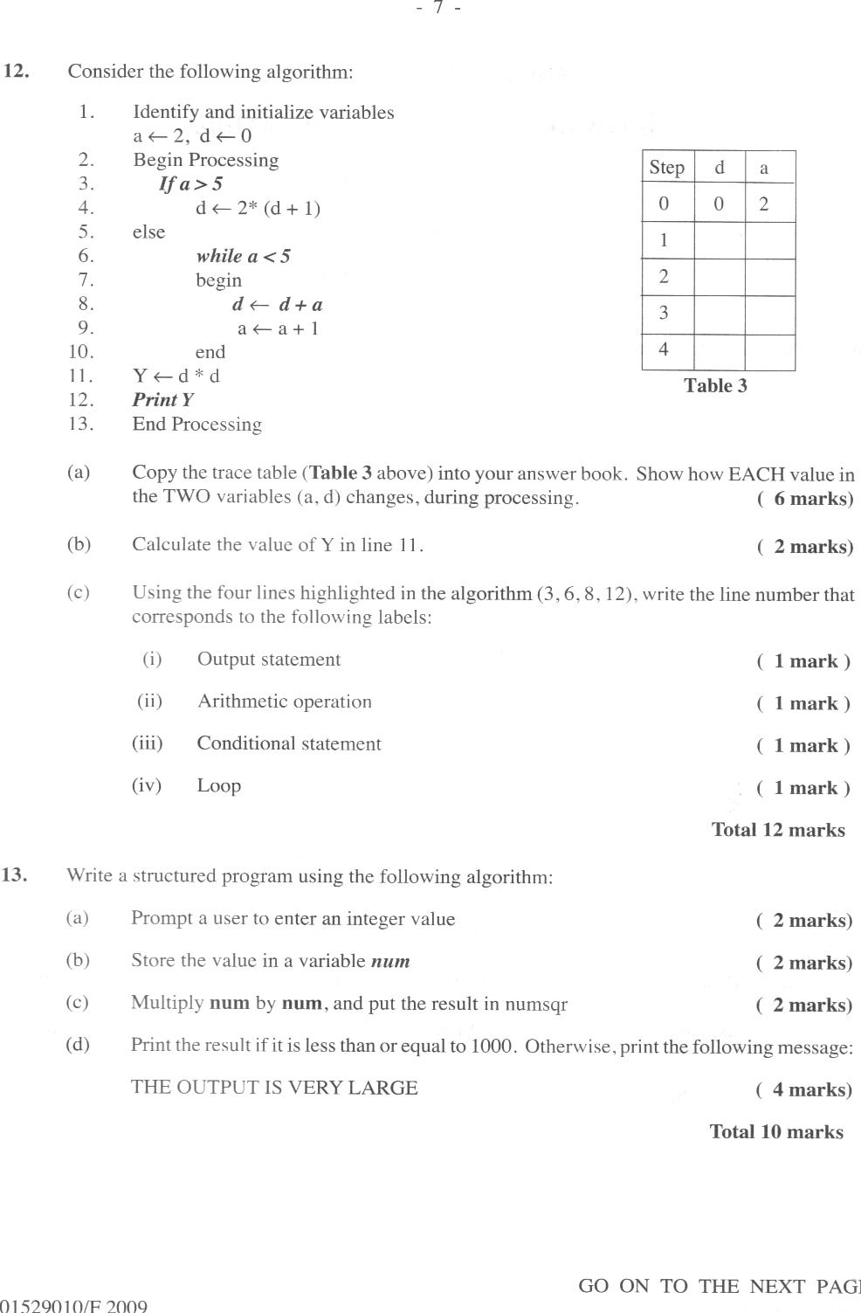
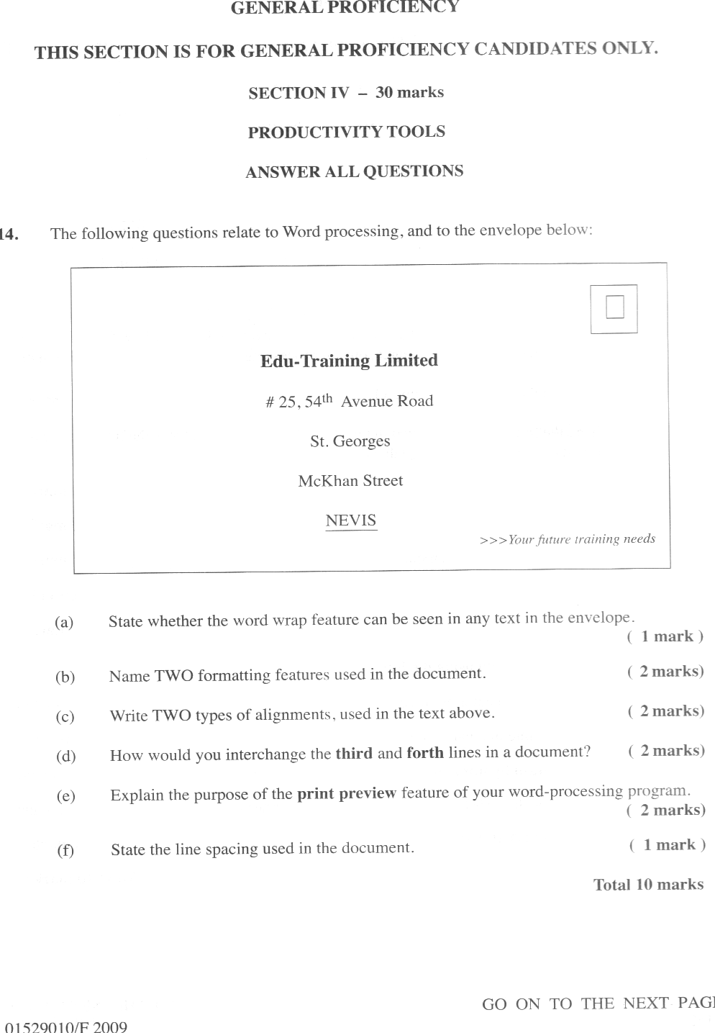
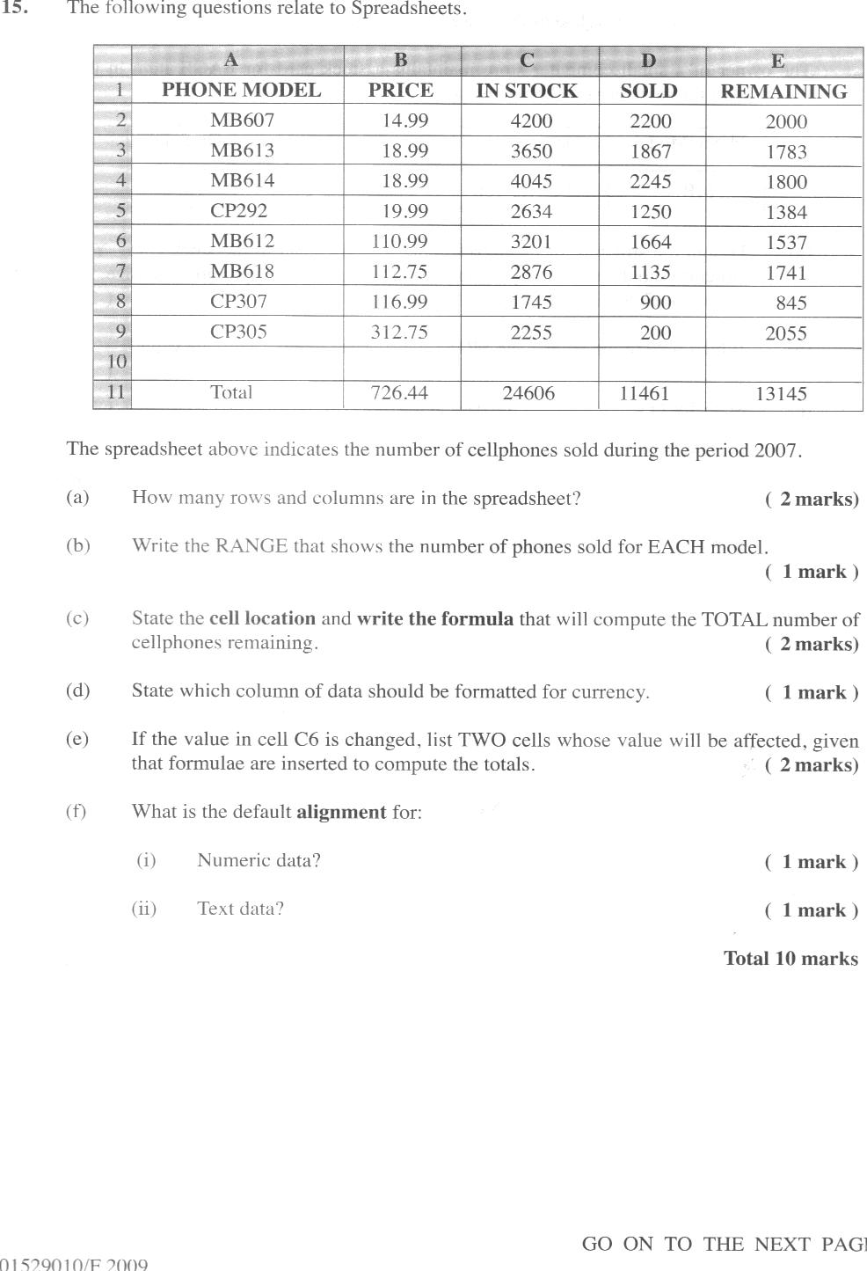

- 10 -
16. The following questions relate to Database Management:
The owner of a small computer store maintains a stock card for EACH item in the store. A sample of the stock card is shown below:

Phone Model | Description | Quantity | Price | On Sale
MB607 | ATT Flip Top | 2209 | 14.99 | No

(a)
Design the structure of a database table to correspond to the stock card. Your table
structure should include appropriate Field Names, Field Type and Field Size. The data
in the 'On Sale' field should only be Yes or No. ( 3 marks)

(b) Which field in the table is the MOST appropriate to have a unique value?
( 1 mark) ( 2 marks)
( 2 marks)
State TWO ways in which the data in the table can be arranged.
(c) (d)
(e)
List TWO meaningful queries that would be of benefit to the storeowner.
The storeowner needs a price list showing the Phone Model, Description and Price.
Explain how this report can be generated. ( 2 marks)
Total 10 marks

